**Bank Loan Report**

**A. Summary**

**Total Loan Applications**

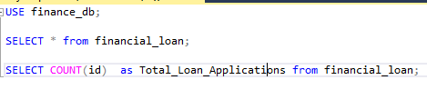



**MTD Loan Applications**





**MOM Loan Applications**

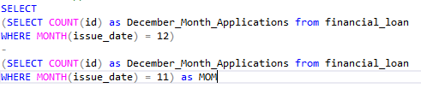



**2. Total Funded Amount**





**MTD Total Funded Amount**





**MOM Funded Amount**

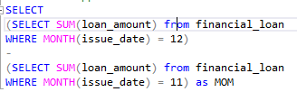



**3. Total Amount Received**





**MTD Amount Received**





**MOM Amount Received**

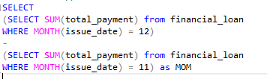



**4. Average Interest Rate**





**MTD Average Interest Rate**





**MOM Average Interest Rate**

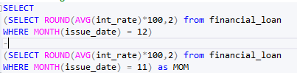



**5. Average DTI**





**MTD Average DTI**





**MOM Average DTI**

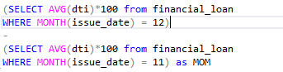



**6. Good Loan Applications**

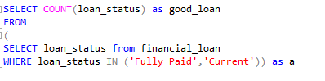



**Percentage of Good loan**

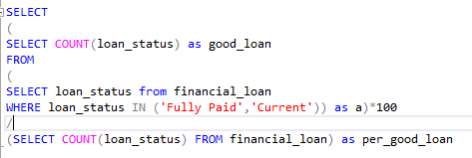



**Total Good Loan Amount**





**Total Good Loan Payment**





**7. Bad Loan Applications**

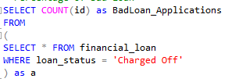



**Bad Loan Applications Percentage**

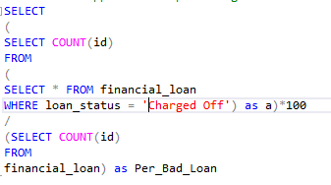



**Bad Loan Amount**





**Bad Loan Payment**





**8. Comparison Loan Status wise**

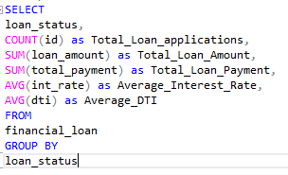

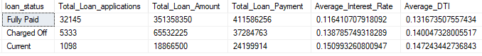

**MTD Loan status wise**

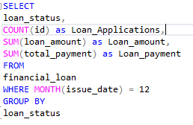

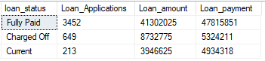

**Month Wise Load Disbursment**

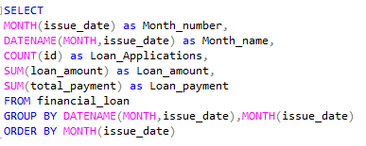

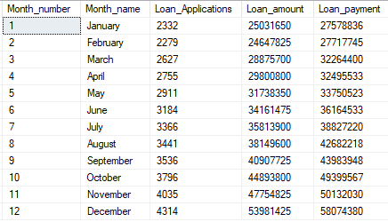

**State Wise Loan Disbursement**

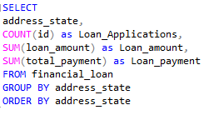

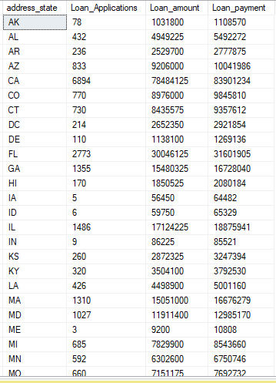

**Term**

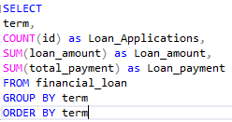

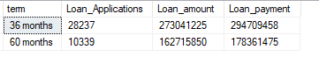

**Employee wise**

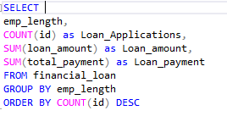

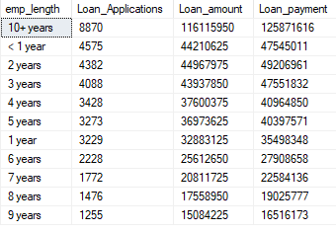

**Purpose wise**

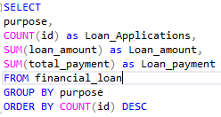

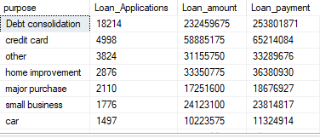

**Home Ownership wise**

